

*AI 407 – Introduction to Robotics*

**Lab 4 Manual**

**Exploring Robotics Fundamentals with Turtlesim**

* **Lab objectives**
* **Introduction to Turtlesim**
* **Exploring ROS 2 commands with Turtlesim**
* **Controlling Turtlesim with Python**
* **Lab Requirements**
* **Software:** Ubuntu 22.04 LTS, ROS 2 Humble
* **Hardware:** Students should work on Lab Devices
* **Before You Start**

Kindly read the manual, review the references if any, before beginning implementation.

* **Introduction to Turtlesim**

Turtlesim is a lightweight 2D simulator included in ROS 2, designed for learning robotics and ROS fundamentals. It provides a simple turtle-like robot that moves in response to commands, making it ideal for beginners to explore ROS concepts like topics, services, and parameters.

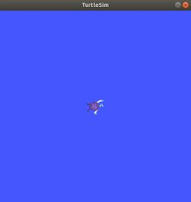

**Key learning aspects of Turtlesim:**

1. **ROS Topics & Messaging:** Users control the turtle by publishing velocity commands to the topic /turtle1/cmd_vel and monitor its position via the topic /turtle1/pose, introducing the publish/subscribe model.
2. **Basic Robotics Principles:** Experimenting with linear and angular velocity helps understand motion and forward kinematics.
3. **Control Algorithms:** Users can implement ROS nodes to move the turtle in patterns like circles or squares, gaining hands-on experience with robot control logic.

* **Exercise 1: Exploring Turtlesim**

**Step 1: Source ROS 2 Environment**

Before running any ROS 2 commands, source the setup file:

*source /opt/ros/humble/setup.bash*

**Step 2: Run the Turtlesim node**

*ros2 run turtlesim turtlesim_node*

**Step 3: Understanding ROS 2 Topics for Turtlesim**

Key topics for controlling the turtle:

* **/turtle1/cmd_vel** → Publishes velocity commands (geometry_msgs/msg/Twist).
* **/turtle1/pose** → Provides the turtle’s current position and orientation (turtlesim/msg/Pose).
  1. To list all active topics:

*ros2 topic list*

* 1. Check the Message Type:

*ros2 topic info /turtle1/cmd_vel*

This will show you the type of the message being used (which is geometry_msgs/msg/Twist).

* 1. Check the Message Structure:

*ros2 interface show geometry_msgs/msg/Twist*

This command displays the structure of the Twist message, which consists of linear and angular components (both of type Vector3).

Vector3 linear:

float64 x # Movement along the x-axis

float64 y # Movement along the y-axis

float64 z # Movement along the z-axis

Vector3 angular:

float64 x # Rotation around the x-axis

float64 y # Rotation around the y-axis

float64 z # Rotation around the z-axis

**Step 4: Controlling Turtle Movement**

To move the turtle, publish a message to /turtle1/cmd_vel. The message type is geometry_msgs/msg/Twist, which contains linear and angular velocity components.

* **Controlling the Turtle Using the Keyboard:**

To control the turtle using the keyboard, run the following command in a new terminal:

*ros2 run turtlesim turtle_teleop_key*

* This command starts a teleoperation node that listens for keyboard inputs and publishes velocity commands to /turtle1/cmd_vel.
* Use the arrow keys, or the keys written in the terminal to move the turtle:
* **Publishing Velocity Commands Manually**
  1. **Example: Move the Turtle Forward**

In a new terminal, publish a velocity command:

*ros2 topic pub /turtle1/cmd_vel geometry_msgs/msg/Twist ‘{linear: {x: 2.0, y: 0.0, z: 0.0}, angular: {x: 0.0, y: 0.0, z: 0.0}}’ --once*

This makes the turtle move forward with a speed of 2.0 m/s.

* 1. **Example: Rotate the Turtle**

To rotate the turtle to the left, publish a message with a positive angular velocity in the z-axis:

*ros2 topic pub /turtle1/cmd_vel geometry_msgs/msg/Twist '{linear: {x: 0.0, y: 0.0, z: 0.0}, angular: {x: 0.0, y: 0.0, z: 1.5}}' --once*

This makes the turtle rotate counterclockwise at an angular velocity of 1.5 rad/s.

**Step 5: Monitor Turtle Pose**

To track the turtle’s position & orientation in real time, subscribe to /turtle1/pose topic using:

*ros2 topic echo /turtle1/pose*

This command displays the turtle’s x, y position, orientation, and velocity as it move

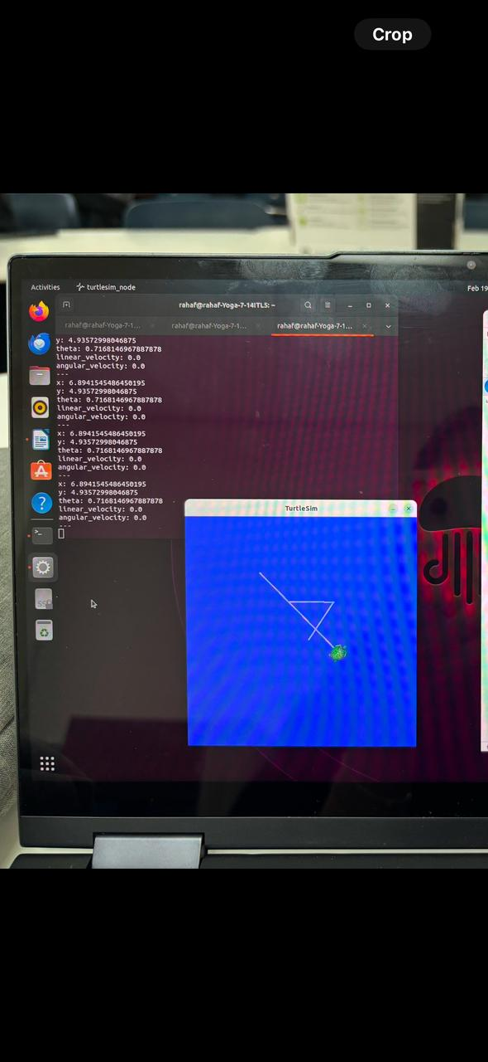

* **Exercise 2: Controlling Turtlesim with Python**

In this exercise, you'll create a ROS 2 package to control the turtle using a Python script. You'll learn how to publish velocity commands programmatically instead of using terminal commands.

**Step 1: Create a New Workspace**

First, create a new workspace with your name (e.g., name_lab4_ws):

*mkdir -p ~/name_lab4_ws/src*

**Step 2: Create a New Package**

First, navigate to your ROS 2 workspace (e.g., name_lab4_ws) and create a package:

*cd ~/name_lab4_ws/src*

*ros2 pkg create --build-type ament_python my_turtle_pkg --dependencies rclpy geometry_msgs*

This creates a package named my_turtle_pkg inside the src folder.

**Step 3: Write the Python Script**

Navigate to the package directory and create a move_turtle.py script:

*cd ~/name_lab4_ws/src/my_turtle_pkg/my_turtle_pkg*

*gedit move_turtle.py*

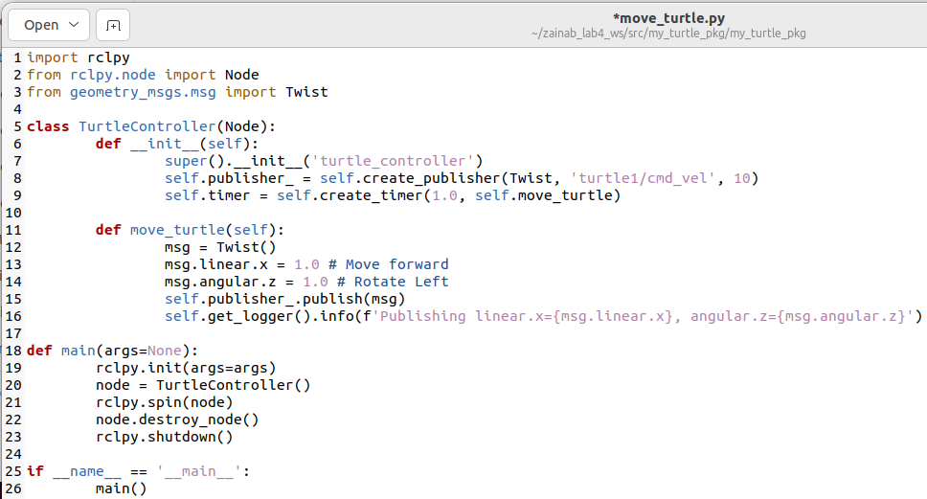

* This script publishes velocity commands to /turtle1/cmd_vel every 1 second.
* The turtle moves forward (linear.x = 1.0) and rotates left (angular.z = 1.0).
* The node logs the published values for debugging.

After you write the code, make it executable

*chmod +x move_turtle.py*

**Step 4: Modify setup.py to Include the Script**

Open setup.py inside my_turtle_pkg and add the entry point:

'move_turtle = my_turtle_pkg.move_turtle:main',

**Step 5: Build the Package**

* Return to your workspace root and build the package:

*cd ~/name_lab4_ws*

*colcon build*

* Source the workspace in the. bashrc file:

source ~/name_lab4_ws/install/setup.bash

**Step 6: Run the Script**

First Run the turtlesim node

*ros2 run turtlesim turtlesim_node*

Then, in another terminal, run your Python script:

*ros2 run my_turtle_pkg move_turtle*

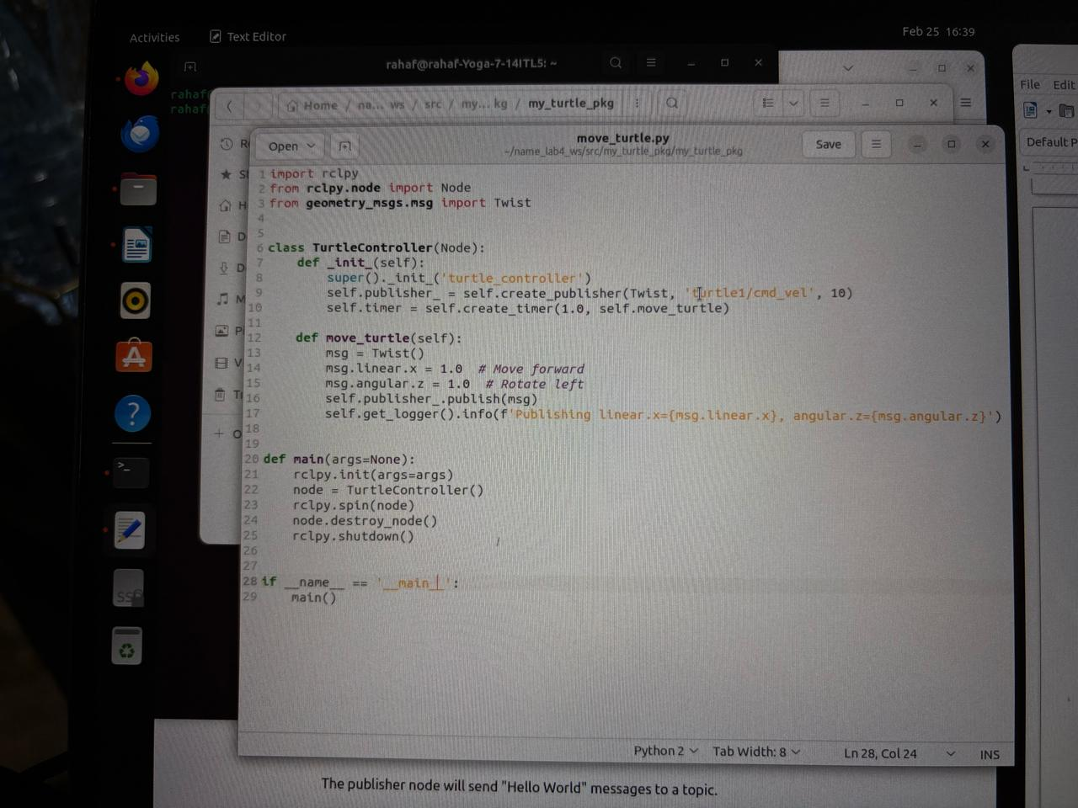

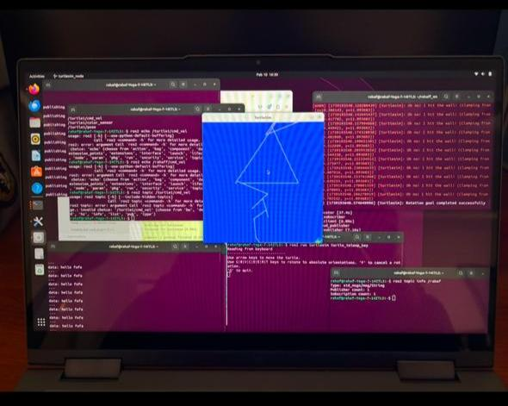

* **Lab activity:**

**Task:** Write a Python script to move the turtle in a square path like this:

1. Provide the source code:

**Import rclpy**

**From rclpy.node import Node**

**From geometry_msgs.msg import Twist**

**Import time**

**Class TurtleSquare(Node):**

**Def __init__(self):**

**Super().__init__(‘turtle_square’)**

**Self.publisher_ = self.create_publisher(Twist, ‘/turtle1/cmd_vel’, 10)**

**Self.run_square()**

**Def run_square(self):**

**Move_cmd = Twist()**

**For _ in range(4): # Repeat for 4 sides of the square**

**Move_cmd.linear.x = 1.0 # Move forward**

**Move_cmd.angular.z = 0.0**

**Self.publisher_.publish(move_cmd)**

**Time.sleep(2) # Move straight for 2 seconds**

**Move_cmd.linear.x = 0.0 # Stop forward motion**

**Move_cmd.angular.z = 1.57 # Turn 90 degrees (approx. pi/2 radians)**

**Self.publisher_.publish(move_cmd)**

**Time.sleep(1) # Rotate for 1 second**

**# Stop the turtle at the end**

**Move_cmd.linear.x = 0.0**

**Move_cmd.angular.z = 0.0**

**Self.publisher_.publish(move_cmd)**

**Def main(args=None):**

**Rclpy.init(args=args)**

**Node = TurtleSquare()**

**Rclpy.shutdown()**

**If __name__ == ‘__main__’:**

**Main()**

1. Explain what you did to make it move in square shape:

Publishing Velocity Commands:

The script uses ROS 2 publishers to send velocity commands to /turtle1/cmd_vel.

The Twist message is used to control the linear (x) and angular (z) velocities.

Moving in a Straight Line:

The turtle moves forward at 1.0 m/s for 2 seconds using:

Move_cmd.linear.x = 1.0

Move_cmd.angular.z = 0.0

This ensures it moves straight for a fixed time.

Making a 90-degree Turn:

The turtle stops forward motion and rotates in place by setting:

Move_cmd.linear.x = 0.0

Move_cmd.angular.z = 1.57 # Approximately 90 degrees (π/2 radians)

It turns for 1 second, which rotates it about 90 degrees.

Repeating for 4 Sides:

The above sequence (move forward → turn 90 degrees) is repeated 4 times to complete a square.

Stopping the Turtle:

After completing the square, the script sets both linear and angular velocities to 0 to stop the turtle.

3. Provide screenshot of the terminal that’s running the code and the Turtlesim window:

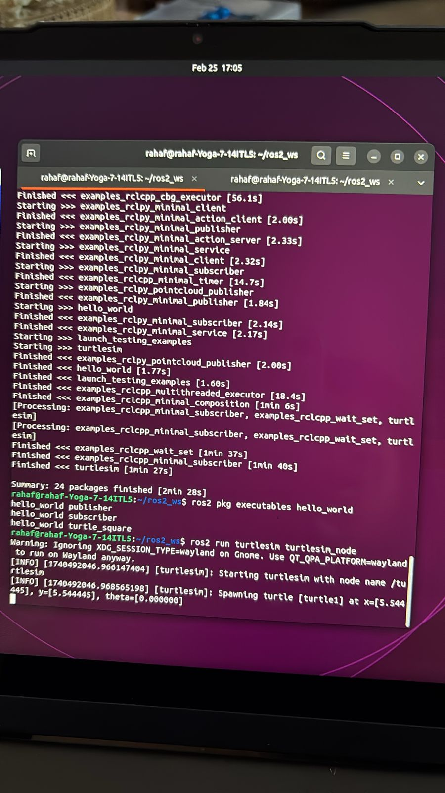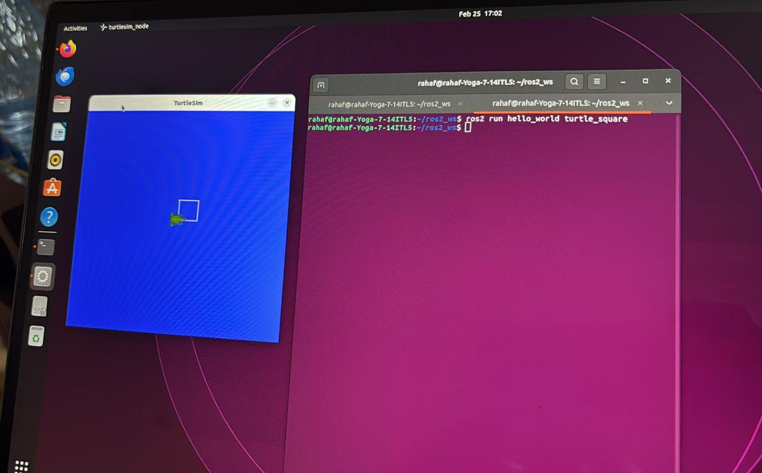

**References**

[Creating a workspace — ROS 2 Documentation: Humble documentation](https://docs.ros.org/en/humble/Tutorials/Beginner-Client-Libraries/Creating-A-Workspace/Creating-A-Workspace.html)